Stock Price Prediction Using Machine Learning

By

***21781A33C4 (R Pavithra)***

***21781A33D0 (S Soniya)***

***21781A33D1 (Sanjana K)***

***21781A33E9 (V Naga Shanthi)***

*Guided by*

***Prof. Ms Raasha***

A Dissertation Submitted to

SRI VENKATESWARA COLLEGE OF ENGINEERING AND TECHNOLOGY, An Autonomous Institution affiliated to ‘JNTU Ananthapur’ in Partial Fulfilment of the Bachelor of Technology (***Computer Engineering***) with Specialization in ***Artificial Intelligence and Machine Learning.***

*May 2024*



**SRI VENKATESWARA COLLEGE OF ENGINEERING AND TECHNOLOGY**

**R.V.S. Nagar Tirupathi Road, Andhra Pradesh– 517127**

**Proposed Solution**

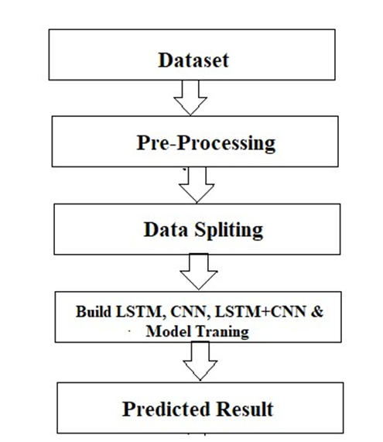

The system presented here composes of five modules:-

1. Input as Dataset
2. Pre processing
3. Data splitting
4. Build & Model train Lstm, CNN and Hybrid approach of LSTM+CNN
5. Output as Predicted Result

Attribute such as: price of open, high, low, close, adjusted close price taken from huge dataset are fed as input to the models for training to pre-process the data techniques like normalization & one hot encoding in applied on dataset. After this data is divided in two sets namely training & testing which are ratio of 80:20 respectively. Then, this set are used to train a model using 3 different approaches: LSTM, CNN and Hybrid approach of LSTM+CNNS. Finally, all these modules are evaluated using Root mean square error.

**Working of LSTM model**

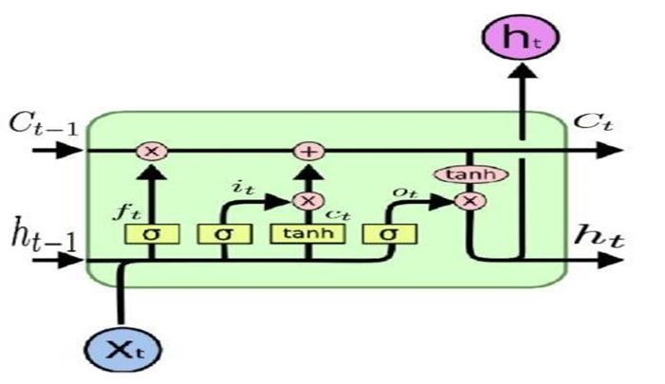

Long Short Term Memory is a kind of recurrent neural network. In RNN output from the last step is fed as input within the present step. It tackled the matter of long-term dependencies of RNN within which the RNN will not predict the word hold on within the long term memory however can offer additional accurate forecasts from the recent info. Because the gap length will increases RNN does not offer an economical performance. LSTM will by default retain the knowledge for a long period of time. It is used for processing, predicting and classifying on the basis of time-series data.

* **Structure of LSTM:**
* LSTM has a chain organization that contains four neural networks and different memory blocks called cells**.**
* LSTM has a new structure called a memory cell. The memory cell makes the decisions about what information to store, and when to allow reading, writing and forgetting.
* A memory cell contains three main gates:
  + Input gate- a new value flows into the memory cell. o Forget gate- a value remains in the memory cell.
  + Output gate- value in the memory cell is used to compute the output.

* **Applications of LSTM includes:**
* Language Modelling Ø Machine Translation
* Image Captioning
* Handwriting generation
* Question Answering Chatbot

**3.2.2. Working of CNN model**

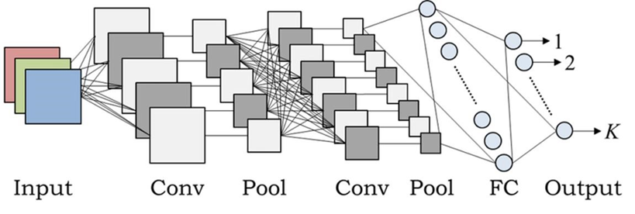

* **Layer of CNN model:** o Convolution o MAX Pooling o Dropout o Flatten o Dense o Activation
* **Convolution:** In the Convolution extract the featured from the input image. It given the output in matrix form.
* **MAX Pooling:** In the MAX polling it takes the largest element from a rectified feature map.
* **Dropout:** Dropout is randomly selected neurons are ignored during training.
* **Flatten:** Flatten feed output into a fully connected layer. It gives data in list form.
* **Dense:** A Linear operation in which every input is connected to every output by weight. It followed by a nonlinear activation function.
* **Activation:** It used sigmoid function and predict the probability 0 and 1.

* **Applications of CNN includes:**
* Decoding Facial Recognition
* Analyzing Documents

##### **3.2.3. Hybrid Approach of LSTM + CNN**

In the hybrid approach, the Convolutional Neural Networks (CNNs) offer benefits in choosing sensible options and Long Short-Term Memory (LSTM) networks have proven sensible skills to find out to learn sequential data. Each approaches are reported to produce improved result. CNNs to possess to convolute filters over every input layer so as to get the simple options and CNNs have shown enhancements in computer vision, natural language processing and different tasks [14]. CNN may be a powerful tool to pick out features in order to improve the prediction accuracy [15]. The capabilities of LSTMs in learning data series by considering the previous outputs [16]

The multiple convolutional filters slide over the matrix to produce a new feature map and also the filters have numerous completely different sizes to generate different features. The Maxpooling layer is to calculate the most value as a corresponding feature to a particular filter. The output vectors of the Max-pooling layer become inputs to the LSTM networks to measure the long-run dependencies of feature sequences. One in all the benefits of the LSTMs is that the ability to capture the sequential data by considering the previous data. This layer takes the output vectors from the dropout layer as inputs. This layer include a set number of units or cells and also the input of every cell is that the output from the dropout layer. The final output of this layer has the same number of units within the network the outputs from LSTMs are merged and combined in one matrix then passed to a fully connected layer. The array is converted into a single output in the range between 0 and 1 using the fully connected layer, in order to be finally classified using sigmoid function [17].